REPAIR CARE
STANDARD SPECIFICATIONS - DRY FIX®/DRY FLEX®

Repair Care systems are designed to ensure the durability of joinery and timber components, with preventative and curative treatments. The following guidance notes and specific Working Methods apply to all repairs which are to be completed using the range of Repair Care DRY FIX® and DRY FLEX® products. All published data sheets and information should be read carefully before commencing work. Full training and further advice are available from Repair Care International Ltd (tel. 01487 830311, fax. 01487 832876 or e-mail salesuk@repair-care.com).
For information on our DRY SEAL™ UN flexible glazing sealant please refer to Standard Specifications - DRY SEAL™ UN.

Repair Care International Products

DRY FIX® 1, 4 & 16 – used as the first “primer coat” application before the appropriate DRY FLEX® product.

DRY FLEX® 1, 4 & 16 – used for completing repairs.

Please refer to full Product Data Sheets, before commencing work – available at www.repair-care.com

Recommended Tools

Repair Care Mini-Profi™ router and cutters, scraper, dosing pistol, mixing board, application knives, Perspex sheets, Repair Care Sander, Repair Care Wood Condition Meter, disposable brushes, MIX & FIX® set, EASY-Q™ WIPES and EASY-Q™ Gloves.

All recommended tools and accessories are available from your usual supplier.

Personal Protective Equipment

When using epoxy resin avoid contact with skin and eyes. During preparation and sanding use appropriate eye protection and fine particle dust masks. When handling and applying the products wear EASY-Q™ Gloves. Change gloves regularly and do not re-use after contact with epoxy resin. When appropriate, wear eye protection (e.g. when working above eye level).

Please refer to full Material Safety Data Sheets and Health and Safety information, before commencing work – available at www.repair-care.com

REPAIR CARE
STANDARD SPECIFICATIONS - DRY FIX®/DRY FLEX®

Preparation

- Remove paint at least 10mm from the area to be treated.
- Remove all decayed and soft timber using a Repair Care Mini-Profi™ router and round cutter. Rather than feather the edge of the area, create a ‘shoulder’ of at least 5mm.
- Ensure the moisture content is no higher than 18%. This can be checked with a wood condition meter.
- If the timber is too wet, it should be allowed to dry naturally.
- Sand off any loose fibres and remove dust and dirt.

Application

- Shake both components of the DRY FIX® and then mix in the MIX & FIX® paper cup using the wooden spatula. Brush the mixed liquid liberally onto the bare wood. If a timber splice is being used the contact areas of the splice and any exposed end grain should also be coated.
- Allow DRY FIX® to penetrate the wood for at least 20 minutes. It can be left for up to 8 hours (DRY FIX® 4 and 16) or up to 2 hours (DRY FIX® 1). Wipe away any excess fluid.
- Dispense the DRY FLEX® using the dosing pistol and mix thoroughly until a completely uniform colour is achieved.
- Apply a thin coat to all areas already coated with DRY FIX®. Complete the repair by adding more DRY FLEX®, using timber inserts or face splices where appropriate and/or specified. Perspex sheets can be used to help create a straight edge.
- Remove excess product leaving a smooth surface.

Finishing

- When the DRY FLEX® is completely cured, remove any Perspex sheets and sand the area to ensure a smooth finish and to give a key for the decorative coating. Remove dust.
- Finish in accordance with the paint specification. The Dulux Weathershield system is particularly suitable (Weathershield preservative primer should only be applied to the bare timber around the repair).

DISCLAIMER:
Although these Working Methods have been drawn up with care and in accordance with current technology, it is for information purposes only and Repair Care International Ltd cannot be held liable for any mistakes or printing errors.
The technical product information has no other value and no binding information. This document (January 2010) supersedes all earlier versions.

WORKING METHODS (PREVENTATIVE) - DRY FIX®/DRY FLEX®

In all cases follow the Standard Specifications above in conjunction with any specific instructions below.

P2 Sealing of sound and open joints.
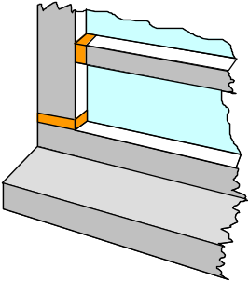
For Preparation, item 2 change to:
Using the Mini-Profi™ router, open the joint along its whole length to a minimum of 10mm wide and 10mm deep.

P4 Repairing splits/cracks in timber.
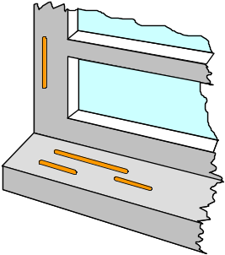
For Preparation, item 2 change to:
Using the Mini-Profi™ router, drill holes 10 mm
deep at both ends of the crack, then open the crack to a
minimum of 10mm wide and 10mm deep.

P5 Repairing natural flaws in timber (Knots etc).

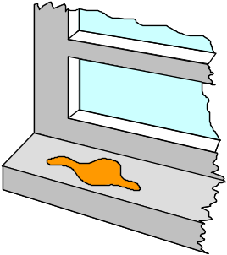
Follow standard specification.

P6 Sealing exposed end grain.

Follow standard specification.
Recommended product is DRY SHIELD™ SK

WORKING METHODS (CURATIVE) - DRY FIX®/DRY FLEX®

In all cases follow the Standard Specifications above in conjunction with any specific instructions below.

C1 Resin only repair of decayed wood.
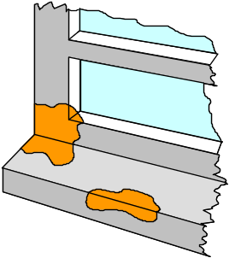
Follow standard specification.

C2 Replacing whole cills, stiles and rails.
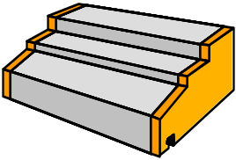
For Preparation:
When cutting the new component allow the following resin gaps between contact surfaces:
DRY FLEX® 1: 5 – 10mm
DRY FLEX® 4 & 16: min. 5mm
All contact surfaces should be clean, dry and free of paint.

C3 Repairs using resin with timber inserts.

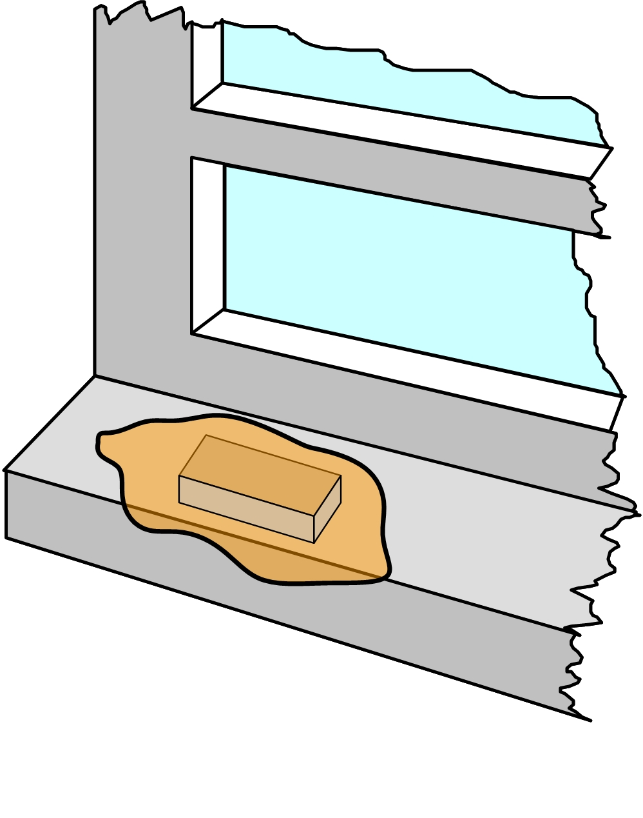
For Preparation:
When cutting the new component allow the following resin gaps between contact surfaces and over the top of the
timber insert:
DRY FLEX® 1: 5 – 10mm
DRY FLEX® 4 & 16: min. 5mm
All contact surfaces should be clean, dry and free of paint.
For Application:
Apply a thin coat of DRY FLEX® to the end grains of the timber insert before positioning in the recess.

C4 Repairs using resin with timber splices.

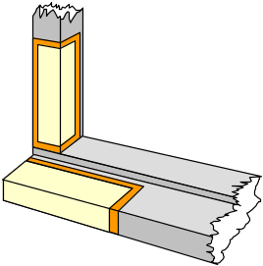
For Preparation:
When cutting the new component allow the following resin gaps between contact surfaces:
DRY FLEX® 1: 5 – 10mm
DRY FLEX® 4 & 16: min. 5mm
All contact surfaces should be clean, dry and free of paint.

REPAIR CARE
STANDARD SPECIFICATIONS - DRY SEAL™ UN

DRY SEAL™ UN is a flexible glazing sealant for replacing linseed oil putties in new or existing windows and for bedding timber glazing beads. It can be painted or stained and is suitable for use on most frames (excluding uPVC) and glass, including sealed double glazed units. As well as existing windows, it can be used to glaze new windows. The following guidance notes and specific Working Methods apply to all procedures which are to be completed using DRY SEAL™ UN flexible glazing sealant. All published data sheets and information should be read carefully before commencing work. Full training and further advice are available from Repair Care International Ltd.
For information on our range of Repair Care DRY FIX® and DRY FLEX® products please refer to Standard Specifications - DRY FIX®/DRY FLEX®.

Repair Care International Products

DRY SEAL™ UN – Flexible glazing sealant for durable replacement of defective putties.

Please refer to full Product Data Sheets, before commencing work – available at www.repair-care.com

Recommended Tools

Repair Care Wood Condition Meter, DRY SEAL™ UN dispensing gun, DRY SEAL™ UN applicator, EASY-Q™ WIPES and EASY-Q™ Gloves.

All recommended tools and accessories are available from your usual supplier.

Personal Protective Equipment

When using DRY SEAL™ UN avoid contact with skin and eyes. During preparatory sanding use appropriate eye protection and fine particle dust masks. When appropriate wear eye protection.

Please refer to full Material Safety Data Sheets and Health and Safety information, before commencing work – available at www.repair-care.com

REPAIR CARE
STANDARD SPECIFICATIONS - DRY SEAL™ UN

Preparation

- Remove all loose/defective putty and beads. Attention should be given to the bottom horizontal and a minimum of 30mm to the verticals.
- Clean and sand the rebate. Ensure all corrosion is removed from metal frames.
- Ensure the moisture content is no higher than 18%. This can be checked with a wood condition meter.
- Clean the glass and, if necessary, use methylated spirits to remove any remaining algal growth.
- Clean and sand the rebate.

Application

- Prime the rebate and allow to dry.
- Apply DRY SEAL™ UN with the dispensing gun.
- Smooth the surface using the DRY SEAL™ UN applicator.

Finishing

- Allow to cure.
- If necessary, remove any excess DRY SEAL™ UN from the glass.
- Finish with a fast drying primer, ideally within 48 hours of application, or in accordance with the paint specification. The Dulux Weathershield system is particularly suitable (Weathershield preservative primer should only be applied to the bare timber around the repair).

DISCLAIMER:
Although these Working Methods have been drawn up with care and in accordance with current technology, it is for information purposes only and Repair Care International Ltd cannot be held liable for any mistakes or printing errors.
The technical product information has no other value and no binding information. This document (January 2010) supersedes all earlier versions.

WORKING METHODS - DRY SEAL™ UN

In all cases follow the Standard Specifications above in conjunction with any specific instructions below.

PG2 Face glazing and back putties.

Follow standard specification.

PG6 Bead glazing.

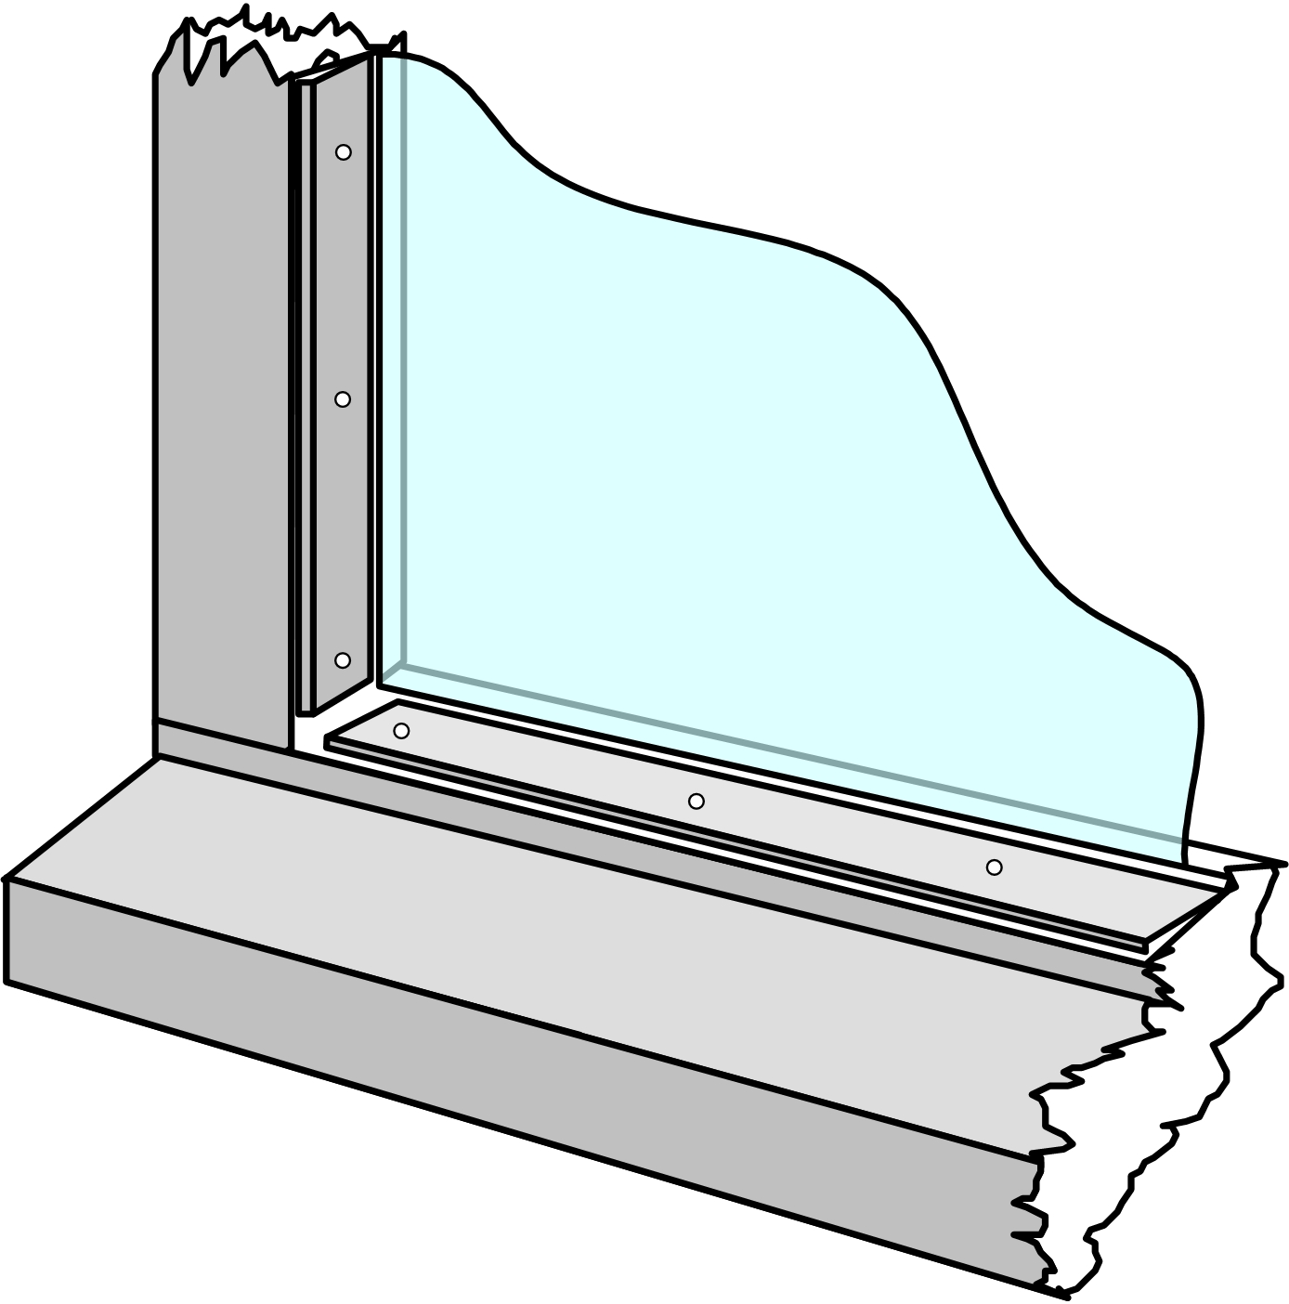
For Application:
Prime the bead.
After application of DRY SEAL™ UN, fix timber bead and allow a minimum of 2mm of DRY SEAL™ UN behind, at each end and underneath the glazing bead.

